Euroscola – a day in the European Parliament
By Jake Kühn (Germany, 2020) 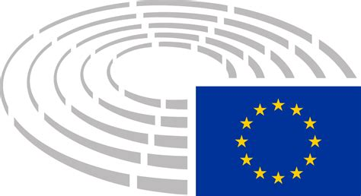
Euroscola is a project by the European Parliament in Strasbourg where students from all over Europe come together to discuss political topics concerning the European Union. My name is Jake and my class won the participation contest to be part of this project. I had the task of being a journalist in the European Parliament for one day. In this article I’m going to present the project, the Parliament and its work and I’m going to comment on it – one thing I can foreshadow: It was a lot of fun!
What is Euroscola?
To participate in Euroscola, your teacher has to enrol your school in the Euroscola-competition, where your class or students of your school then have to send in some form of creative documents that deal with the EU-Parliament. My class, for example, had to create websites where we should present imaginary parties for the EU-election 2019 with appealing campaigning videos. One website of two girls in my class won the national competition of Euroscola and so my class was able to participate in the one day workshop at the EU-Parliament in Strasbourg, where we represented Germany.
Euroscola’s purpose is to integrate young European people in the EU, show them the work of the EU-Parliament, and connect students from all over Europe with each other and encourage European patriotism for peace and solidarity within the European Union.
The Journey
My class had two days off from school and made a class trip to Strasbourg – another reason to recommend participating in Euroscola. Strasbourg is an old but modern city with lots of restaurants and old classy houses. Euroscola even sponsored a meal – as much tarte as we liked!
The EU-parliament is bigger than one would imagine from the news. I spoke with a Hungarian student who wanted to study architecture and he was stunned with the architecture inside, but there was also the critique by some people that the building was too ostentatious and inefficient and that all this would cost too much money.
Young Reporters and the Committees
First, we all had breakfast and got to know each other better. I was very surprised by how good all the students in Europe could speak English and that we could communicate so naturally. Then we were welcomed by Luis Martínez-Guillén, head of the European Parliament Liaison Office, and two speakers in the actual plenum of the European Parliament, where we could sit on the seats of the members. Some chosen students, the speakers of the countries, presented their school and hometown. Then we could ask some questions about the European Union and its policies – most of them were about Brexit. A lot of the questions were answered quite well with a lot of understanding of the students’ issues, but sometimes they dodged some questions a bit, especially when critique on the European Union’s current policy came up.
Then we had lunch. Here was one ironic and quite critical thing: The European Parliament committed itself to climate neutrality until 2050 and to a Green New Deal and called Climate Emergency just a few weeks ago … and the parliament served us big hamburgers needing several litres of water and producing tons of methane and it didn’t even taste that good because it was only beef, bread and cheese. Meanwhile, vegetarians got a small portion of rice.
During lunch, students could form groups and fill out a quiz where the questions were asked in all the different languages of the European Union, so the students had to work internationally together or cheated by using Google Translate. There was also a contest where you could post an Instagram-picture in the EP under the Hashtag #Euroscola.
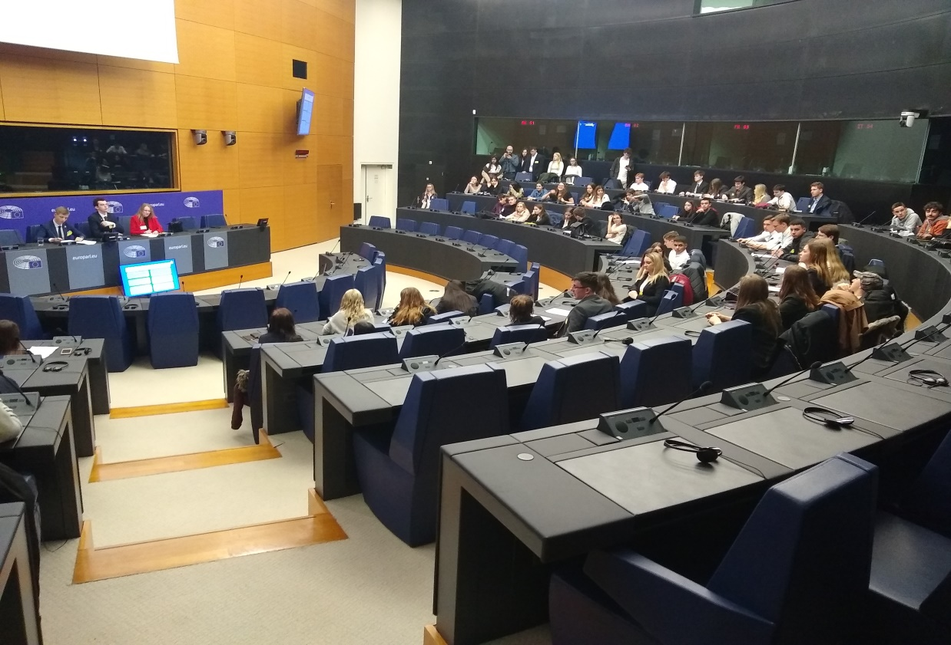
After lunch, the young reporters and the other students split up. The others were drawn into different groups where they could go into parliamentary committees. There they chose speakers for each topic who later presented their results on which they voted. Here was a coincidence: Nearly all speakers who were elected were from Ireland, they did their job very well and were extremely well informed and of course, as Irish, their English was far superior to everyone else’s. The groups were working on the topics: Work & Education, Inner Security & Human Rights, Ecology, Immigration & Integration, and the Future of Europe. In the committees, they had to debate and agree on several motions, just like the real politicians do every day.
Meanwhile, we journalists were shown around the parliament, could ask the speakers some additional questions – also mostly about Brexit – and got to know each other’s countries and schools better. We also voted on the best Instagram picture of the contest. Then we went in several committees where we watched the others voting on their proposals.
When the other students were done with their debates, we all went to the plenum together. There, the speakers of the groups were asked questions about the compromises of their groups. On every topic, the questioning went for ten minutes and all the students voted on the motions – every proposal was passed by the plenum.
After that, the victors of the Instagram contest were praised and the four winner teams of the quiz game had to make another quiz in front of everybody where they were asked questions about music and the European Union.
In the end, we were praised for our knowledge, behaviour and team spirit and left the Parliament. My class nearly missed the train home but in the end, we made it.
The Other Students
I was surprised on how similar we were. Everyone could speak perfect English and there were no great differences in our cultures, views, or education levels. There was one difference in our presentation: The other countries’ students all had dress codes with suits and dresses and they seemed very grateful to take part in Euroscola, while some students – head on us from Germany – came normally clothed in sweatpants and completely unprepared and unorganized. We were also the only country with a welcome speech shorter than 3 minutes, on which the other students were actually quite thankful. Politically, all European students also had very similar values and views. Most of the students agreed on the ground values Democracy, European Unionism, Peace, Ecology, Rule of Law, Anti-Racism, Anti-Nationalism and a Liberal Drug Policy. What surprised me, was that when we were asked if the Euro would be a reasonable valuta for the European Union, most of the students agreed – even the ones from countries who don’t have the Euro and the ones from countries that struggle economically with it. Also, many students were surprisingly quite tolerant to nuclear energy as a way to take on emissions.

Résumé
I would definitely recommend Euroscola! It was really interesting and impressive to get to know students from all over Europe and really brought the pupils together. We also learned a lot about the practical work of the EU and it was quite nice to sit on the seat of a parliamentarian. Asides from the few critique points I already brought up, the only issue was that it didn’t last longer. If your class is interested in politics and communicating a lot in English and if you have a few people who aren’t afraid of talking in front of a crowd, then I highly recommend Euroscola to you. Euroscola is in my opinion a great project to bring together young Europeans, but it doesn’t really affect many students, only around 500. It would be great, if everyone could have a chance to get to know Europe and the European Union better, because we need it. I think no one who took part in Euroscola would ever think of going to war against other European countries or think of separate cultures, because one thing comes clear if you participate in Euroscola: We all are the same people, we have one European culture and we should and have to work together!
